Ex No 1 | Creating a UI prototype using Figma
8/July/2025 | Creating a UI prototype using Figma

AIM:
To create an interactive and visually appealing UI prototype using Figma, demonstrating the process of designing user interfaces for web or mobile applications and simulating user interactions for usability testing and design validation.

Step 1: Set Up Your Figma Project
- Create a Figma Account: If you don't already have one, sign up at figma.com.
- Start a New File: Click on the "+" button or "New File" to start a new project.
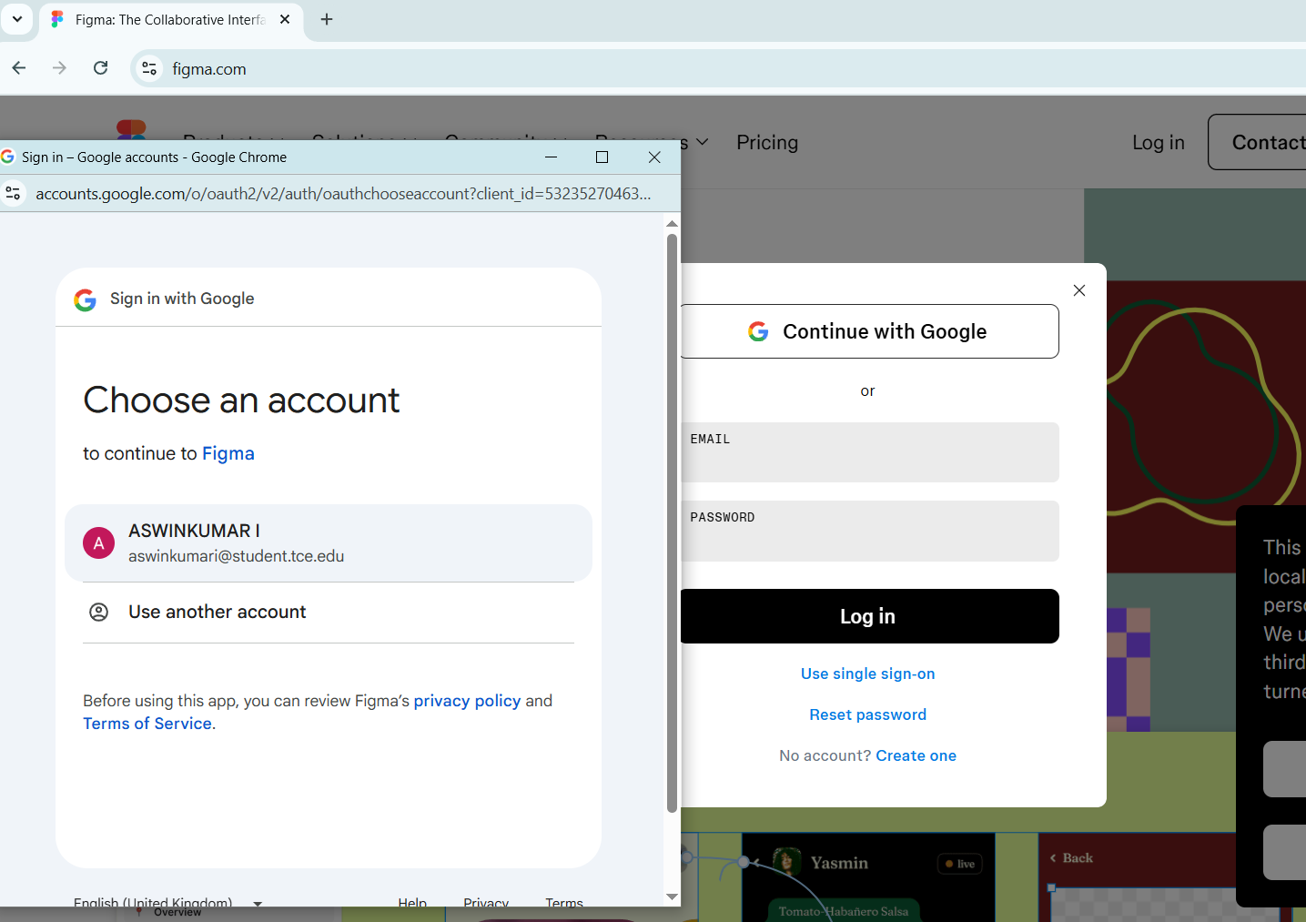
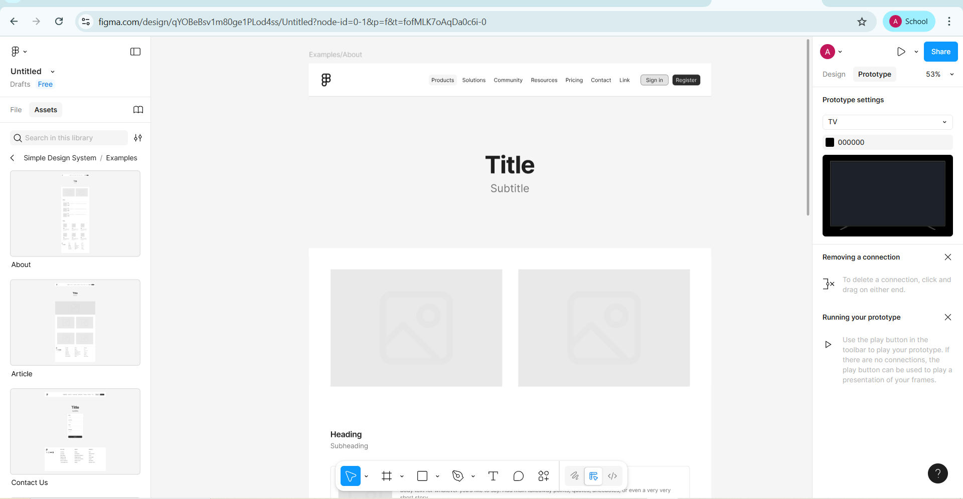

Step 2: Plan Your Design
- Define Your User Flow: Outline the key screens and interactions in your application.
- Sketch Your Ideas: Use a notebook or whiteboard to sketch out rough layouts of your screens. 

Step 3: Design Your UI in Figma
- Set Up Frames: Frames are the basic building blocks in Figma, similar to artboards in other design tools. Create a frame for each screen in your application.
  - Use the Frame tool (F) and set the desired dimensions (e.g., 1440x1024 for a desktop app).
- Add UI Elements: Use Figma's tools to add shapes, text, buttons, images, etc.
  - Shapes: Use the Rectangle (R), Line (L), and other shape tools to create buttons, cards, etc.
  - Text: Use the Text tool (T) to add text. Choose appropriate fonts, sizes, and colors.
  - Images: Drag and drop images or use the Place Image option.
  - Icons: Use Figma’s built-in library or plugins like Feather Icons to add icons.
- Use Components: Create reusable components for elements like buttons, headers, and footers.
  - Create a component by selecting an element and pressing Cmd + Alt + K (Mac) or Ctrl + Alt + K (Windows).
- Organize Layers: Keep your layers panel organized by naming layers and grouping related elements.

Step 4: Prototype Interactions
- Add Interactions: Switch to the Prototype tab in the right sidebar.
  - Select an element and drag the blue circle to the frame it should navigate to.
  - Define interactions (e.g., on click, navigate to the next screen).
- Set Animation Styles: Choose how transitions between screens should animate (e.g., dissolve, slide).

Step 5: Share and Test
- Preview Your Prototype: Click the Present button (play icon) in the top-right corner to interact with your prototype.
- Share with Others: Click the Share button to generate a shareable link.
  - Adjust permissions to allow others to view, comment, or edit.

Step 6: Iterate and Refine
- Gather Feedback: Use comments to gather feedback from stakeholders or testers.
- Make Adjustments: Iterate on your design based on feedback.

Additional Tips
- Use Plugins: Explore Figma’s plugins for additional functionality like image placeholders, icons, and more.
- Collaborate in Real-Time: Figma allows multiple users to work on the same file simultaneously.
- Learn from Others: Explore Figma Community to find inspiration and UI kits that can accelerate your design process.

Example UI Flow for a Team Application (BOOKNGO)
- Login Screen:
  - Frame: 1440x1024 for a desktop app
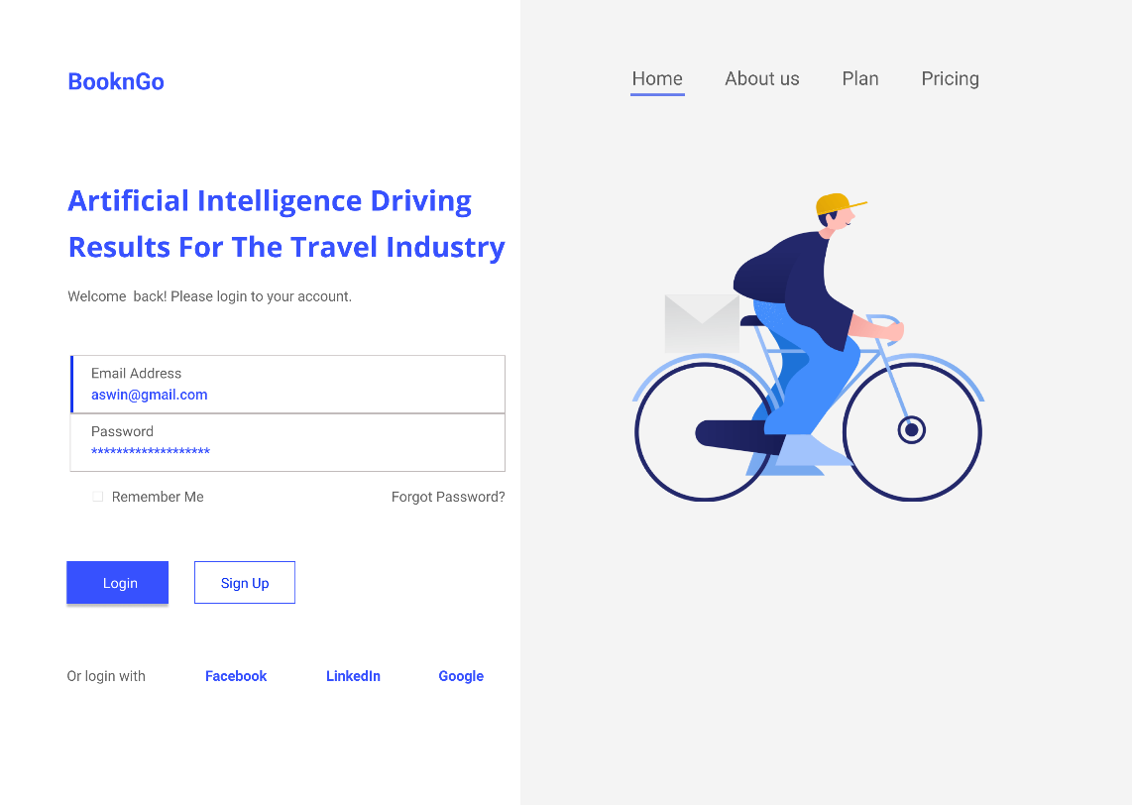
  - Elements: Logo, Username field, Password field, Login button, Signup link.

- Home Screen:
  - Frame: 1440x1024 for a desktop app
  - Elements: Header, Navigation bar, Content cards, Action buttons.
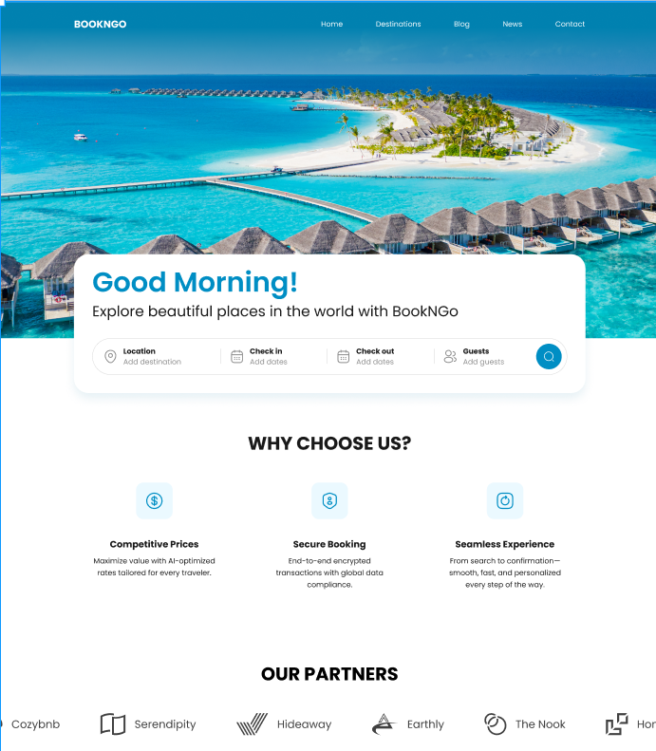

- Details Screen:
  - Frame: 1440x1024 for a desktop app
  - Elements: Back button, Title, Image, Description, Interaction buttons.
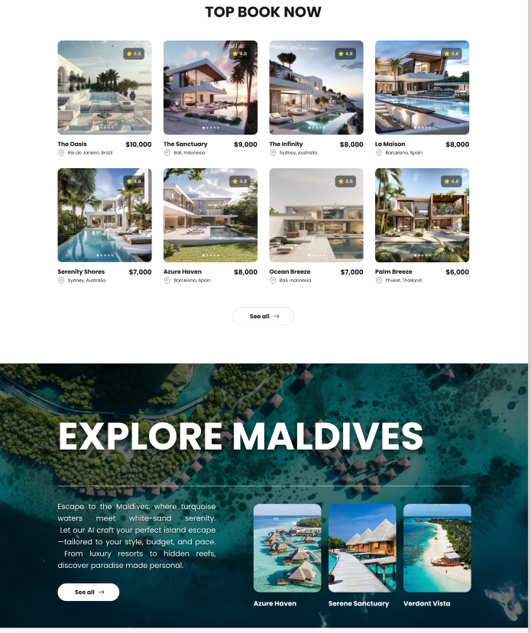

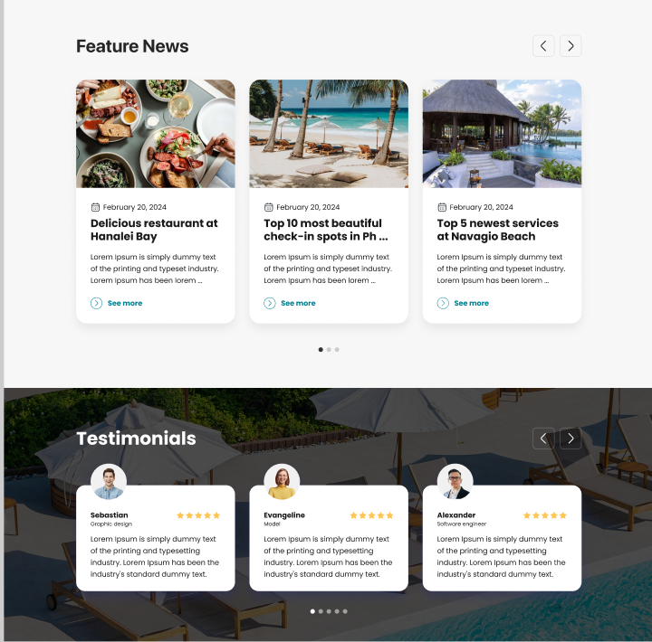

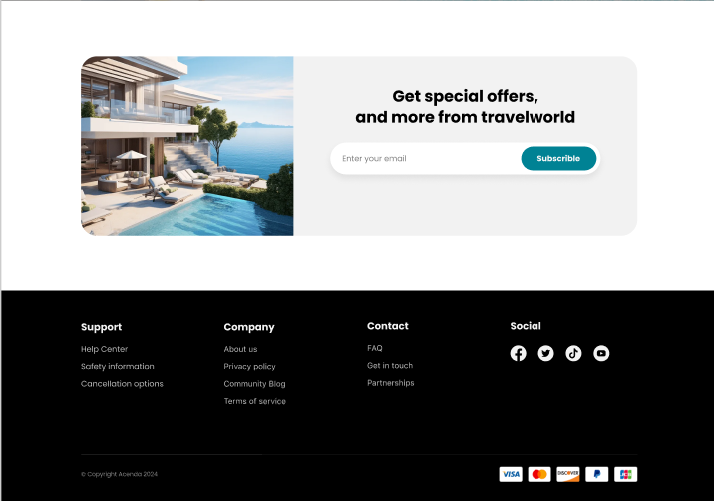

APPLICATION: HOSTEL BOOKING APP
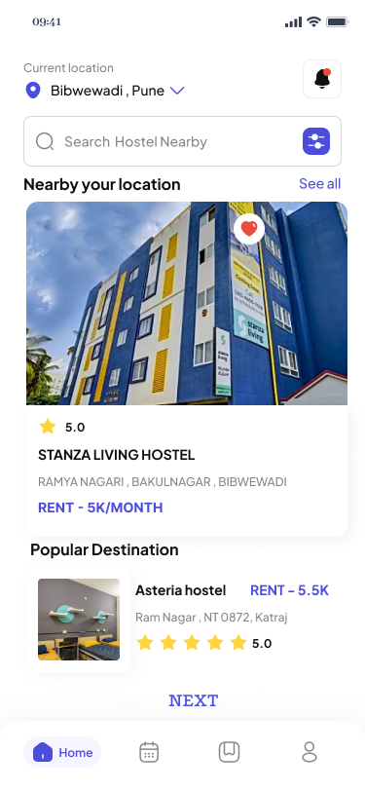
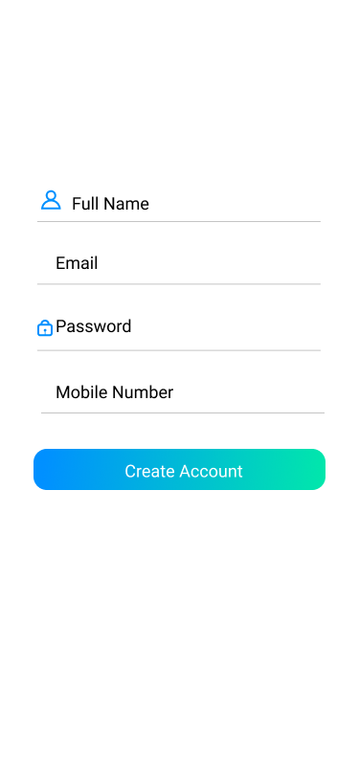
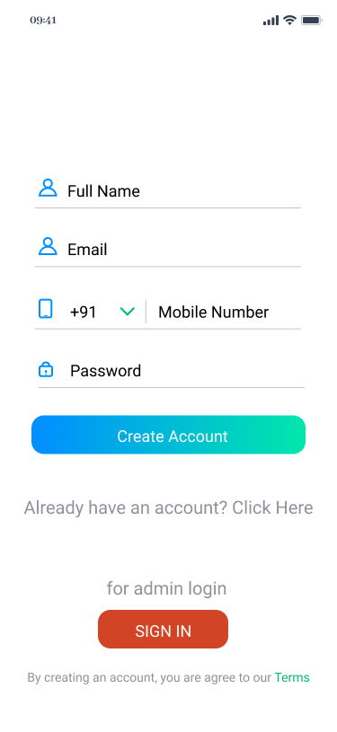
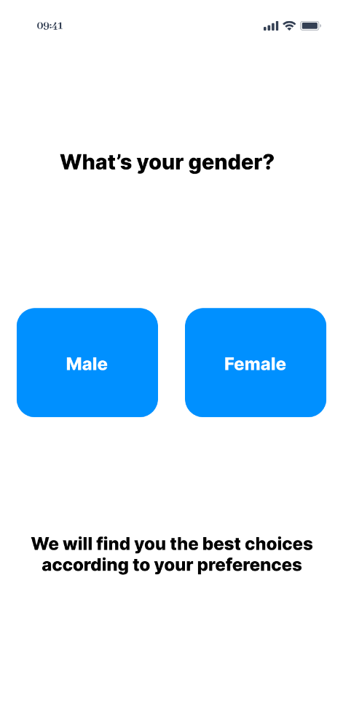

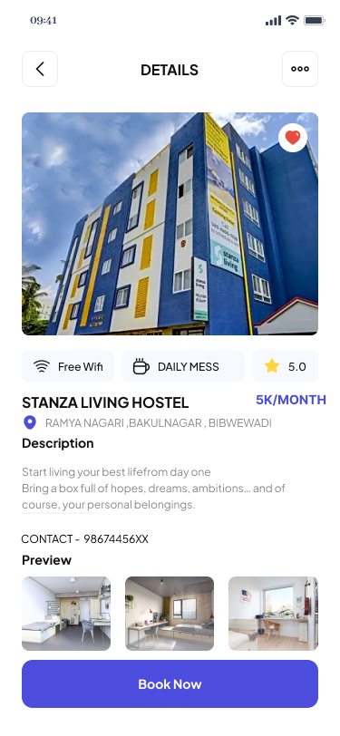
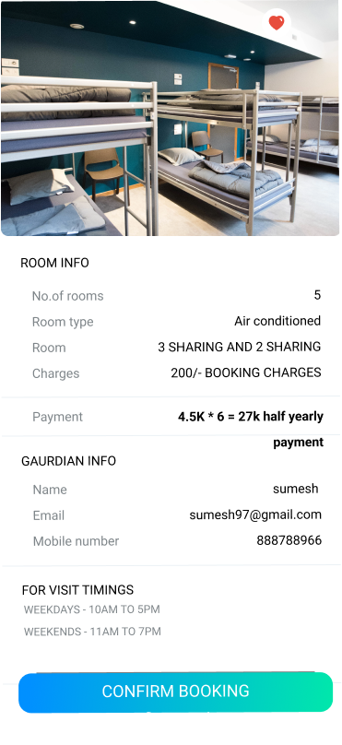

Result:
The complete UI prototype was successfully designed using Figma, covering all major screens and user flows. It includes interactive wireframes for the homepage, booking engine, search results, itinerary details, and user dashboard.

